HMS/HSDM Office for Postdoctoral Fellows
NIH/NSF Training Template for Grant Submission

The Office for Postdoctoral Fellows (http://postdoc.hms.harvard.edu) at Harvard Medical School was founded in 2001, began offering programming in 2004, and given a dedicated office space in 2007, further demonstrating the institution's commitment to the advanced training and mentoring of HMS postdoctoral fellows. The Office for Postdoctoral Fellows (OPF) collaborates with many offices and organizations within HMS, as well as at local, regional, and national levels to address the training needs of postdoctoral fellows across the institution to achieve its mission.

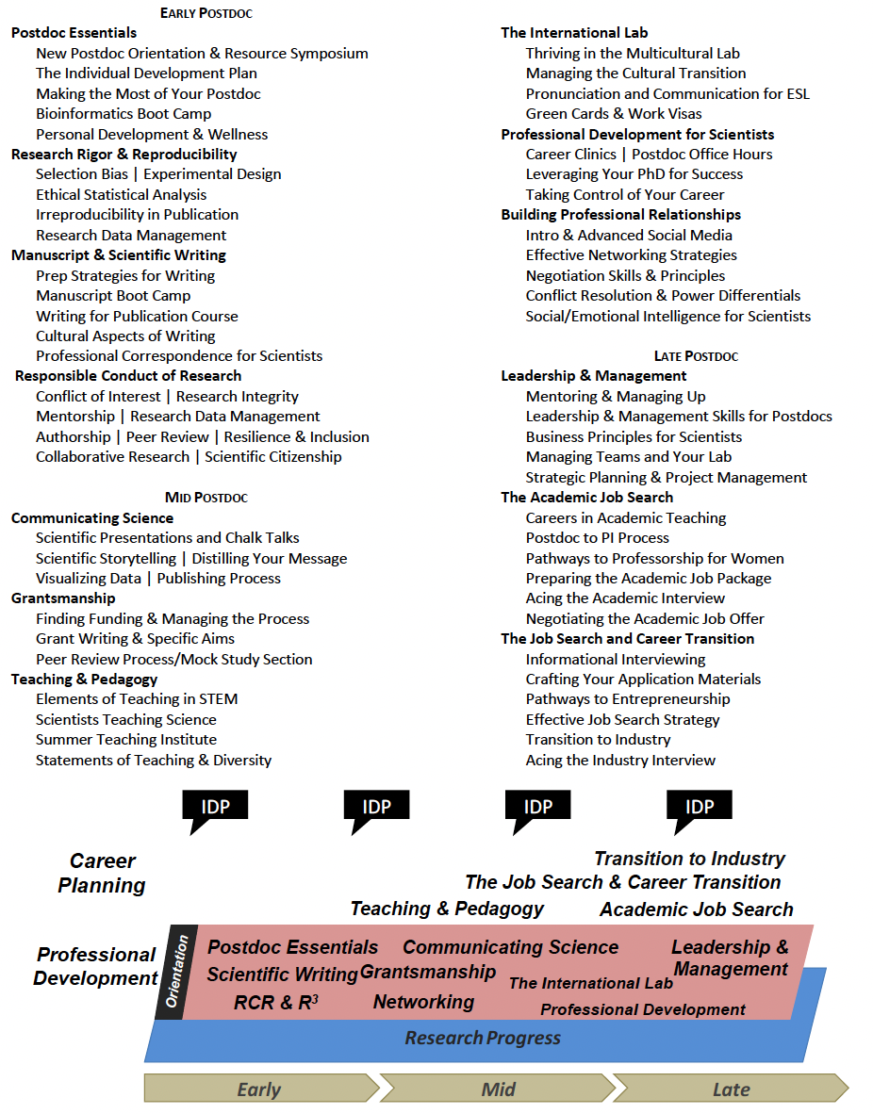
The OPF enhances the development and experience of the postdoctoral community by recognizing the valuable contributions of postdoctoral scholars, developing a firm foundation on which to build a comprehensive training and career development experience, encouraging individual responsibility, fostering mentoring and cultivating a sense of community. Through a combination of administrative initiatives and educational activities, the OPF offers timely and practical programming that adds value to the postdoctoral experience and evolves with the ever-changing training landscape. The office has created a curriculum that expands the portfolio of postdoc competencies through research, career, professional, and personal development while addressing specific issues of early, mid, and late stage trainees. Throughout their tenure, fellows can participate in a curriculum of workshops, panel discussions, seminars, and networking opportunities designed to advance lab management skills, grantsmanship, communication, academic and industry career exploration, as well as work/life and cultural considerations (see figure). The implementation of this curriculum is essential in enhancing the training experience and in preparing postdoctoral fellows for the next stages of their careers regardless of their endpoint. In addition, postdoctoral fellows benefit from access to one-on-one coaching to explore career options, seek feedback on application material preparation, and discuss resources for skills enhancement. To supplement the professional development activities of the office, a lending library is available to postdoctoral fellows with dozens of titles ranging from writing an NIH proposal to career options in the biotech sector.

From the very start of the postdoc appointment, we encourage training plan discussions between postdoctoral fellows and their faculty mentors while providing templates, guidance, and quarterly training for these meetings. The OPF provides Mentorship Guidelines and an IDP Annual Planning Tool which help define expectations for the mentor-mentee relationship, laboratory norms, research and career support, and professionalism. In combination, these mentoring instruments are designed to link research goals with career development and progress toward independence. They are meant to foster an ongoing and recurring discussion that involves evaluation, goal setting, and feedback, with input from both postdoc and faculty mentor.

Responsible Conduct of Research (RCR) training is mandatory at HMS for all postdoctoral fellows, regardless of funding source. Since 2015, the OPF is responsible for tracking participation, scheduling sessions, recruiting faculty speakers, and facilitating sessions along with the Center for Bioethics. Each RCR session is a 90-minute discussion covering: Authorship, Research Data Management, Peer Review, Mentoring, Collaboration, Conflict of Interest, Research Integrity, Resilience & Inclusion, and Scientific Citizenship.

James Gould, PhD
Director, HMS/HSDM Office for Postdoctoral Fellows

